Code:
import javax.swing.*;
import java.awt.*;
import java.awt.event.*;
import java.text.ParseException;
import java.text.SimpleDateFormat;
import java.util.Date;

class EmptyFieldException extends Exception {
public EmptyFieldException(String message) {
super(message);
}
}

class InvalidRollNumberException extends Exception {
public InvalidRollNumberException(String message) {
super(message);
}
}

class InvalidDateException extends Exception {
public InvalidDateException(String message) {
super(message);
}
}

class NullSelectionException extends Exception {
public NullSelectionException(String message) {
super(message);
}
}

public class LibraryBookIssueSystem extends JFrame implements ActionListener {

JLabel lblTitle, lblName, lblRoll, lblBookTitle,
lblCategory, lblBookType, lblIssueDate,
lblReturnDate, lblRemarks;

JTextField txtName, txtRoll, txtBookTitle,
txtIssueDate, txtReturnDate;

JTextArea txtRemarks;

JComboBox<String> comboCategory;

JRadioButton rbNew, rbOld;
ButtonGroup bgType;

JButton btnIssue, btnReset, btnExit;

public LibraryBookIssueSystem() {

setTitle("Library Book Issue System");
setSize(550, 620);
setLayout(null);
setDefaultCloseOperation(JFrame.EXIT_ON_CLOSE);
getContentPane().setBackground(new Color(230, 240, 250));

Font labelFont = new Font("Arial", Font.BOLD, 14);

lblTitle = new JLabel("Library Book Issue System");
lblTitle.setFont(new Font("Verdana", Font.BOLD, 22));
lblTitle.setBounds(110, 20, 350, 30);
add(lblTitle);

lblName = new JLabel("Student Name:");
lblRoll = new JLabel("Roll Number:");
lblBookTitle = new JLabel("Book Title:");
lblCategory = new JLabel("Book Category:");
lblBookType = new JLabel("Book Type:");
lblIssueDate = new JLabel("Issue Date:");
lblReturnDate = new JLabel("Return Date:");
lblRemarks = new JLabel("Remarks:");

lblName.setFont(labelFont);
lblRoll.setFont(labelFont);
lblBookTitle.setFont(labelFont);
lblCategory.setFont(labelFont);
lblBookType.setFont(labelFont);
lblIssueDate.setFont(labelFont);
lblReturnDate.setFont(labelFont);
lblRemarks.setFont(labelFont);

lblName.setBounds(40, 80, 150, 25);
lblRoll.setBounds(40, 130, 150, 25);
lblBookTitle.setBounds(40, 180, 150, 25);
lblCategory.setBounds(40, 230, 150, 25);
lblBookType.setBounds(40, 280, 150, 25);
lblIssueDate.setBounds(40, 330, 150, 25);
lblReturnDate.setBounds(40, 380, 150, 25);
lblRemarks.setBounds(40, 440, 150, 25);

add(lblName);
add(lblRoll);
add(lblBookTitle);
add(lblCategory);
add(lblBookType);
add(lblIssueDate);
add(lblReturnDate);
add(lblRemarks);

txtName = new JTextField();
txtRoll = new JTextField();
txtBookTitle = new JTextField();
txtIssueDate = new JTextField("dd/MM/yyyy");
txtReturnDate = new JTextField("dd/MM/yyyy");

txtName.setBounds(200, 80, 250, 30);
txtRoll.setBounds(200, 130, 250, 30);
txtBookTitle.setBounds(200, 180, 250, 30);
txtIssueDate.setBounds(200, 330, 250, 30);
txtReturnDate.setBounds(200, 380, 250, 30);

add(txtName);
add(txtRoll);
add(txtBookTitle);
add(txtIssueDate);
add(txtReturnDate);

String categories[] = {
"Select Category",
"Programming",
"AI",
"Databases",
"Networking"
};

comboCategory = new JComboBox<>(categories);
comboCategory.setBounds(200, 230, 250, 30);
add(comboCategory);

rbNew = new JRadioButton("New Edition");
rbOld = new JRadioButton("Old Edition");

rbNew.setBackground(new Color(230, 240, 250));
rbOld.setBackground(new Color(230, 240, 250));

bgType = new ButtonGroup();
bgType.add(rbNew);
bgType.add(rbOld);

rbNew.setBounds(200, 280, 120, 30);
rbOld.setBounds(330, 280, 120, 30);

add(rbNew);
add(rbOld);

txtRemarks = new JTextArea();
JScrollPane sp = new JScrollPane(txtRemarks);
sp.setBounds(200, 440, 250, 70);
add(sp);

btnIssue = new JButton("Issue Book");
btnReset = new JButton("Reset");
btnExit = new JButton("Exit");

btnIssue.setBounds(70, 530, 130, 40);
btnReset.setBounds(220, 530, 100, 40);
btnExit.setBounds(360, 530, 100, 40);

add(btnIssue);
add(btnReset);
add(btnExit);

btnIssue.addActionListener(this);
btnReset.addActionListener(this);
btnExit.addActionListener(this);

setVisible(true);
}

public void actionPerformed(ActionEvent e) {

if (e.getSource() == btnIssue) {

try {

String name = txtName.getText().trim();
String roll = txtRoll.getText().trim();
String book = txtBookTitle.getText().trim();
String issueDate = txtIssueDate.getText().trim();
String returnDate = txtReturnDate.getText().trim();

if (name.isEmpty() || roll.isEmpty() || book.isEmpty()
|| issueDate.isEmpty() || returnDate.isEmpty()) {

throw new EmptyFieldException(
"All required fields must be filled!");
}

if (!roll.matches("\\d+")) {
throw new InvalidRollNumberException(
"Roll Number must contain digits only!");
}

int rollNo = Integer.parseInt(roll);

if (comboCategory.getSelectedIndex() == 0) {
throw new NullSelectionException(
"Please select a Book Category!");
}

if (!rbNew.isSelected() && !rbOld.isSelected()) {
throw new NullSelectionException(
"Please select Book Type!");
}

SimpleDateFormat sdf = new SimpleDateFormat("dd/MM/yyyy");
sdf.setLenient(false);

Date issue = sdf.parse(issueDate);
Date ret = sdf.parse(returnDate);

if (ret.before(issue)) {
throw new InvalidDateException(
"Return Date cannot be earlier than Issue Date!");
}

JOptionPane.showMessageDialog(this,
"Book Issued Successfully!\nRoll No: " + rollNo,
"Success",
JOptionPane.INFORMATION_MESSAGE);

}

catch (EmptyFieldException ex) {
JOptionPane.showMessageDialog(this,
ex.getMessage(),
"Empty Field Error",
JOptionPane.ERROR_MESSAGE);
}

catch (InvalidRollNumberException ex) {
JOptionPane.showMessageDialog(this,
ex.getMessage(),
"Invalid Roll Number",
JOptionPane.ERROR_MESSAGE);
}

catch (NullSelectionException ex) {
JOptionPane.showMessageDialog(this,
ex.getMessage(),
"Selection Error",
JOptionPane.ERROR_MESSAGE);
}

catch (InvalidDateException ex) {
JOptionPane.showMessageDialog(this,
ex.getMessage(),
"Date Error",
JOptionPane.ERROR_MESSAGE);
}

catch (NumberFormatException ex) {
JOptionPane.showMessageDialog(this,
"Roll Number must be numeric!",
"Number Format Error",
JOptionPane.ERROR_MESSAGE);
}

catch (ParseException ex) {
JOptionPane.showMessageDialog(this,
"Invalid Date Format! Use dd/MM/yyyy",
"Date Format Error",
JOptionPane.ERROR_MESSAGE);
}

catch (Exception ex) {
JOptionPane.showMessageDialog(this,
"Unexpected Error: " + ex.getMessage(),
"Error",
JOptionPane.ERROR_MESSAGE);
}

finally {
JOptionPane.showMessageDialog(this,
"Operation Completed");
}
}

else if (e.getSource() == btnReset) {

txtName.setText("");
txtRoll.setText("");
txtBookTitle.setText("");
txtIssueDate.setText("");
txtReturnDate.setText("");
txtRemarks.setText("");

comboCategory.setSelectedIndex(0);
bgType.clearSelection();
}

else if (e.getSource() == btnExit) {
System.exit(0);
}
}

public static void main(String[] args) {
new LibraryBookIssueSystem();
}
}
ScreenShot:
Issue 1:
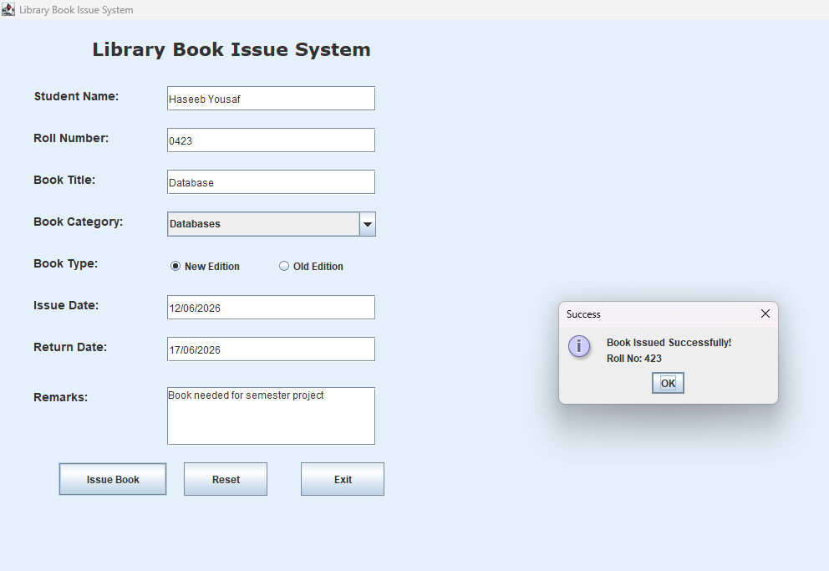

Issue 2:
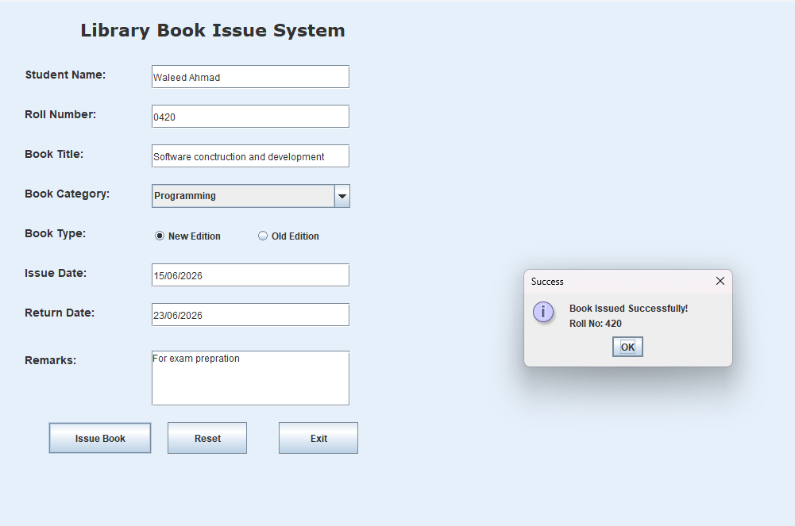
Error:
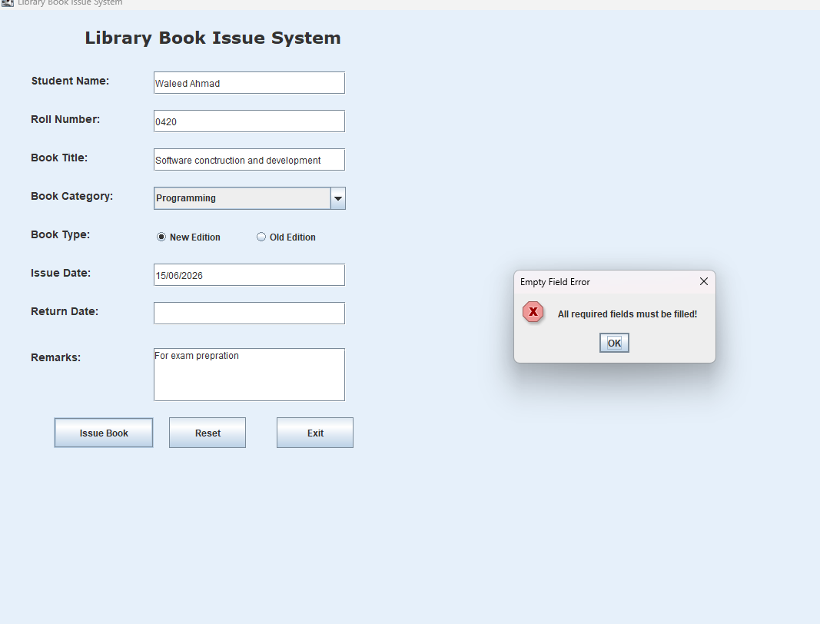

Reset:
